Title (Times New Roman 12 points)
○author 1 ¹，author 2 ¹，author 3 ² ( Times New Roman 10 points )
¹ affiliation 1，² affiliation 2 ( Times New Roman 10 points )

1. Introduction (Times New Roman 10 points )

2. Experimental (Times New Roman 10 points )

3. Results and discussion (Times New Roman 10 points )

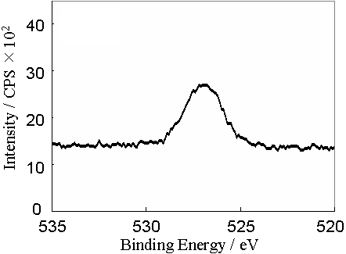
(1) The Abstracts should be used Times New Roman fonts.
Fig. 1 sample.
(2) The Abstracts must be no more than A4 one page
with 25 mm margins.
(3) The Abstract should include:
∙ The title of your presentation, size 12, bold, centered.
∙ The names of all authors in size 10, normal, centered, using letters (1, 2, etc.) as superscripts to identify each author with a different address. The name of the presenting author should be marked the circle.
∙ The main text (it may contain tables and graphs) in size 10, normal, full justification.
∙ References (if necessary) in size 10, normal, full justification.

Abstract deadline is September 30, 2009. All abstracts should be submitted by the E-mail.
E-mail adress: ismm2009@eng.u-toyama.ac.jp

Any inquiries about the abstract may be sent to follows.
Fax : +81-76-445-6707
E-mail adress: ismm2009@eng.u-toyama.ac.jp

