Service Ecosystems Innovation in
Multi-level Adaptive Cycles Model Perspective

Kyoichi Kijima
Tokyo Institute of Technology
2-12-1 Ookayama, Meguro-ku, Tokyo Japan

Abstract
A service system, one of the fundamental concepts of service research, is a dynamic configuration of people, technologies and organizations and shared information that create and deliver value to customers, providers and other stakeholders. A crucial way to create new value by a service system is to introduce new or significantly improved products (goods or services), processes, organizational institutions, and marketing methods in business practices or the marketplace, i.e., innovation in a broad sense. Innovation is indeed the fundamental source of significant value creation by a service system.
In this talk we identify a service system as an ecosystem with adaptive cycle and shed light on innovation carried out by a network of such service ecosystems in a sustainable way. For that aim, we develop a new framework, Multi-level Adaptive Cycles Model, based on Panarchy concept in Systems Sciences and Transition Management Theory. The former gives epistemological viewpoints and the latter provides ontological ones in a complementary way. Then, we analyze service ecosystems innovation in terms of the model focusing especially on its contribution to societal sustainability, referring to some cases and examples.
Some of new insights obtained by this research are: (1) it is legitimate to see a service system itself as an ecosystem taking a form of adaptive cycle, whichever it goes well or fails. (2) However, in order to achieve social sustainable development we need to describe a holistic picture of networks of such service ecosystems and to argue service ecosystems innovation. (3) Service ecosystems innovation is social innovation where networks of such service ecosystems at a level of hierarchy of society transform, or “revolt”, to another networks of service ecosystems at the higher level. Here dynamic structural change of service ecosystems from a level to an upper level in societal hierarchy is crucial in service ecosystems innovation.
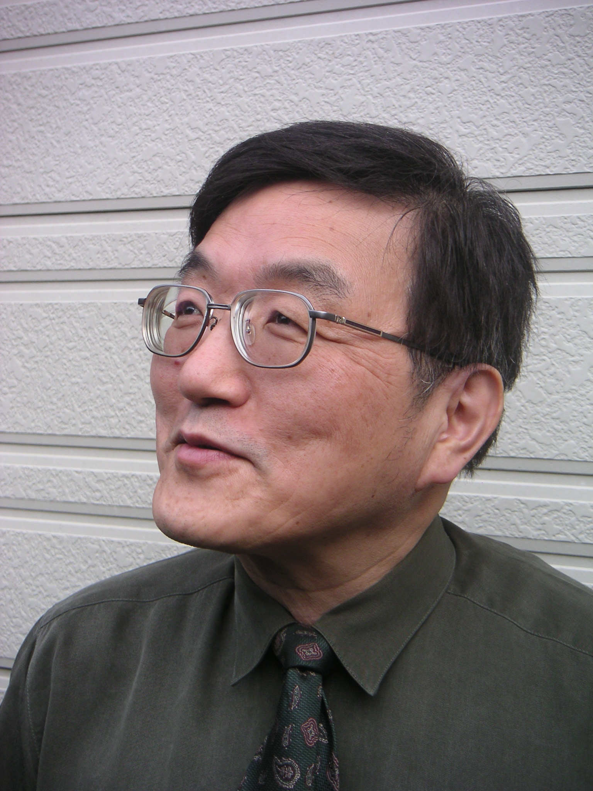

Short Curriculum Vitae of Kyoichi Kijima

As of July, 2014

Kyoichi Kijima is Professor of Decision Systems Science, Tokyo Institute of Technology and Visiting Professor to Hull University Business School, UK, and School of Business Management, Bandung Institute of Technology, Indonesia.
He is a member of International Society for Knowledge and Systems Sciences (ISKSS) and served as Vice President of the Society. He is a member of the International Society for the Systems Sciences (ISSS), where he served as President of the Society in 2007. He served as Vice-President of the International Federation of Systems Research (IFSR). He is also a member of the International Academy of Systems and Cybernetic Science (IASCS), and of World Organisation of Systems and Cybernetics (WOSC). Recently he has been taken initiative as Editor-in-Chief to publish a new and “endless” book series “Translational Systems Sciences” from Springer Japan since 2013.
His main research interest is in systems science/thinking, especially in decision systems science and service systems science. He has been organized international intensive workshops and symposia on service systems science at Tokyo Tech annually since 2008.
He not only has published more than hundred refereed publications in high quality international journals but also is a member of the international committee for journals including Systems Research and Behavioral Sciences, Journal of Service Technology and Management, Risk Management, Journal of Systems Science and Complexity, Asian Journal of Management Science and Applications, and International Journal of Knowledge and Systems Sciences.
He was in charge of conducting a Service Science, Solutions and Foundation Integrated Research Program funded by Japan Society of Science and Technology (JST) from 2010 till 2012. He also worked as Director of “Training Program for Design Innovators of Social Service Values” funded by Ministry of Education, Japan.

