Template for JAIST HLD symposium

First Author, Second Author

Affiliation of the First and Second Author

Abstract : Authors who are presenting at JAIST Human Life Design Area Symposium should use this template for your preparation of manuscript.

Keywords : HLD, symposium, JAIST

1. Introduction

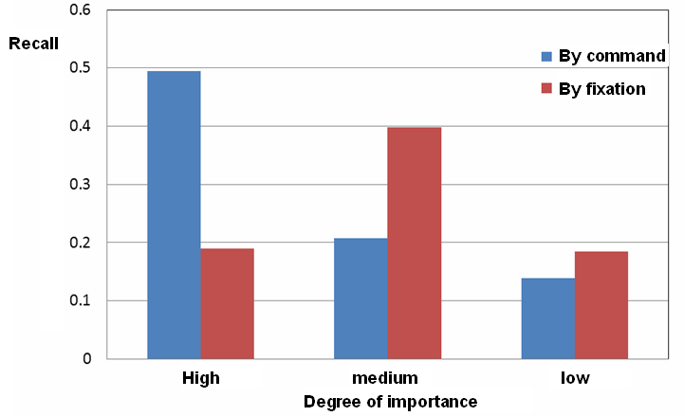
This template is for your preparation of your manuscript. Oral speakers as well as poster presenters should use this template. Format such as font type, size, number of column, should not be changed. The authors should follow this template.

2. Page Limit

Page limit depends on the type of your presentation.

2.1 Oral Presentation

The manuscript for each oral presentation is limited from 2 to 4 pages. No additional page is allowed.

2.2 Poster Presentation

The manuscript for each poster presentation is limited to 1 page. No additional page is allowed.

3. Miscellaneous

3.1 Equation

Each equation must be presented by following equation number as an example below:
                                   

3.2 Figures, Tables, and Citation

Large figures and tables may span across both columns. A Table heading should appear above the table. A Figure captions should be placed below the figure. Use the abbreviation such as “Fig. 1”.

All figures and tales must be numbered. Make sure that the resolution of the figure or picture is high enough for “press quality”.

When you refer to an article, please describe it by number like this [1].

Table 1. An example of Table

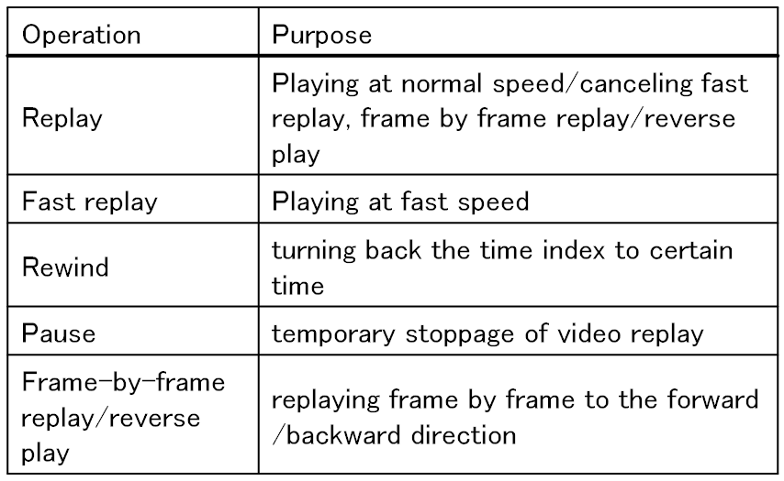

Figure 1. This is an example figure

4. Conclusion

All the manuscripts for JAIST HLD symposium should be prepared by following this template. If you have any questions, please ask area chairs of the symposium.

Acknowledgment

Acknowledgment should be placed here if needed.

References
[1] A. Lastname1, B. Lastname2, “Writing HLD paper is fun,” International Journal of JAIST, Vol. 1, No. 2, pp. 1-10, 2000.
[2] C. Lastname3, D. Lastname4, “History of the International Collaborative Research in JAIST,” International Journal of JAIST, Vol. 2, No. 3, pp. 100-120, 2010.

