Future WINE 2026 Poster Presentation Abstract Template

Taro Kanazawa¹, Sakura Toyama^{1,2}, Yuta Fukui³, Hanako Gifu¹, and Hiroshi Hokuriku¹
¹College of Science and Engineering, Kanazawa University
²Wireless Hub, Japan Science and Technology Agency
³National Institute for Science and Technology
{**,**,**,**,**}@ac.jp

Introduction
The template is designed for the abstract of the International Symposium on Future Wireless Networks (Future WINE) 2026 Poster Session. The length of the abstract should be within 1 page.

Tables and Figures
Tables and Figures should be numbered sequentially. Number the Tables with Roman numerals such as I, II, III. Use the abbreviation for Figures such as “Fig. 1” using Arabic numerals. The following is an example of a Figure caption. The style of Tables should apply to the IEEE Editorial Style Manual.

TABLE I: Example performance comparison.

Method | Metric 1 | Metric 2
Baseline A | 0.00 | 0.00
Baseline B | 0.00 | 0.00
Proposed | 0.00 | 0.00

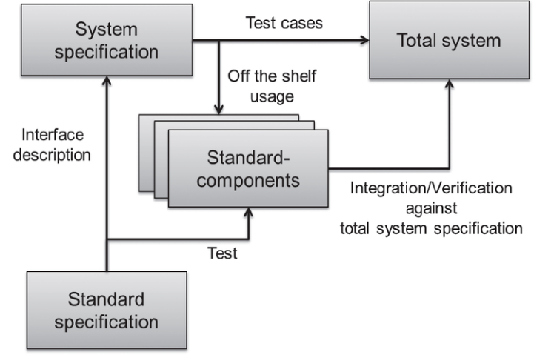
Fig. 1: Example system integration using standard components.

Acknowledgements
This work was supported by XXXXX Grant Number XXXXXXXX

References
[1] B. Klaus and P. Horn, Robot Vision. Cambridge, MA: MIT Press, 1986.
[2] J. S. Turner, “New directions in communications,” IEEE J. Select. Areas Commun., vol. 13, pp. 11-23, Jan. 1995.
[3] C. Janow and D. W. Waugh, “Guidance and control components for space applications,” in Proc. Nat. Electronics Conf., 1994, vol. 24, pp. 30-35.
NOTE: For the citation of books, journal articles, and conference proceedings, see the Editing References section of the IEEE Editorial Style Manual.

