(Appended form)
JAIST Gymnasium Use/Rental Application
Date:
To the President of Japan Advanced Institute of Science and Technology
（Applicant）
Affiliation（Address if an applicant does not belong to JAIST）
Name:
（Student Number）
Contact phone number:
Contact e-mail:
Please confirm following gymnasium use/rental request.
Organization name
Date & time  (include set-up & clean-up） | Date: , Time:  *if you need to apply for several days use, please attach a separate document.
Number of people | student: faculty: others:
Purpose / event
Facility requested  （refer to the next page） | Full gym ・ Half gym(A) ・ Half gym(B)  Choose one and put a circle
Parking use  （outsider only） | Yes ・ No
Purpose of parking use
Remarks
＊ In case JAIST Extracurricular Organization uses the gymnasium with non-members, Extracurricular Organization Off-Campus Activity Application must be submitted as well.
----------------------------------------------------------------------
The gymnasium use of above activity is approved.
In case of disaster occurrence, the gymnasium use permit may be cancelled by JAIST.
,20
President of Japan Advanced Institute of Science and Technology
(How to fill out the form)
- For Affiliation, a student need to fill in his/her “program and year” and a faculty or a staff member need to fill in his/her “School or Department, etc.”
- If an applicant does not belong to JAIST, please write the address of the person.
- If an applicant is a JAIST student, please write his/her student number.
- In case of emergency or for the safety confirmation at times of disaster, JAIST contact the person in charge. In order to contact smoothly, please arrange emergency contact network in the group with a responsibility.
- Please bring a first-aid kits on site.
- If the gymnasium use is over a few days and the purpose or members, etc. are the same, please submit a document (voluntary form) as well.
- For Date & Time should include amount of time needed for activity, including set-up and clean-up.
- For facility requested, please choose full or half use and put a circle.
*Basketball, futsal and tennis are full gym use only.
- A JAIST member is prohibited to use a gymnasium parking lot.
- A personal data on this application is not used for any purpose other than the gymnasium use.

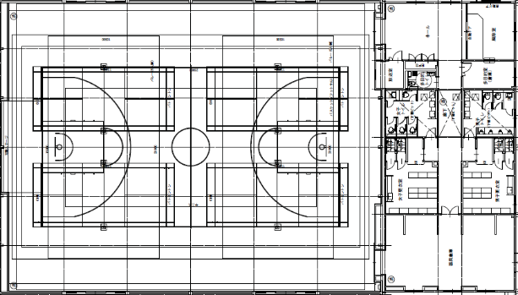
ホール
器具倉庫
Ａ
Ｂ

(How to enter the gymnasium)
- A JAIST member needs his/her ID card to access to the gymnasium as an entrance key.
- For local residents and those who do not belong to JAIST, please contact Disasters Prevention Center(extension: 1000) by intercom at the entrance and inform the name of the person in charge or the organization name.

(Appended form/ example)
JAIST Gymnasium Use/Rental Application
Date: October 15, 2018
To the President of Japan Advanced Institute of Science and Technology
（Applicant）
Affiliation（Address if an applicant does not belong to JAIST） 1st year Master’s program

Name: Ichiro Sentan
（Student ID） 1800000
Contact phone number: 090-0000-0000
Contact e-mail: jaist@jaist.ac.jp
Please confirm following gymnasium use/rental request.
Organization name | Basketball Circle
Date & time  (include set-up & clean-up） | Date: December 1, 2019 (Sat.) ,Time: 9 : 00 ~ 12 : 00  *if you need to apply for several days use, please attach a separate document.
Number of people | student: 15 faculty: others:
Purpose / event | Practice and game of basketball
Facility requested  （refer to the next page） | Full gym ・ Half gym(A) ・ Half gym(B)  Choose one and put a circle
Parking use  （outsider only） | Yes ・ No
Purpose of parking use
Remarks
＊ In case JAIST Extracurricular Organization uses the gymnasium with non-members, Extracurricular Organization Off-Campus Activity Application must be submitted as well.
----------------------------------------------------------------------
The gymnasium use of above activity is approved.
In case of disaster occurrence, the gymnasium use permit may be cancelled by JAIST.
,20
President of Japan Advanced Institute of Science and Technology

